Beginning 1/01/2019, we will be converting from using Transflo to the Cam Scanner App. If you are a regional or OTR driver who ever uses Transflo to submit your paperwork to the payroll department, then you will need to download this app to your smart phone and begin using it.
Instructions:
- Go to the app store and search “Cam scanner” and download the app with a similar icon as shown above.
- When you open the app, it will require you to create a username and password to login.
- After you login, you will see this screen, to capture a page or multiple pages click the icon.
- You can use the scroll bar to select “Single” or “Batch”. The “Batch” selection will allow you to take pictures of multiple pages.  Use the icon o take one picture or multiple pictures.  ***Note: there is also an option to scan an ID card, if you need to send your DL or medical card to the safety department. *** | 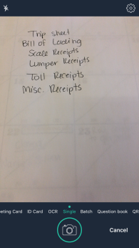
- After taking pictures of the documents you need to send. Click the “Finish” button that appears at the bottom, right-hand corner.
- You will be directed back to this screen.  - Select the document you wish to send by clicking on it. | 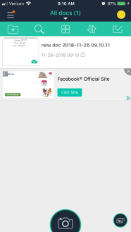
- After you select the document you wish to send. You will click the “More button” and then click “email”. | 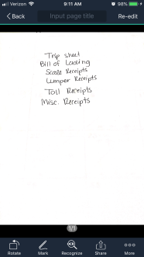
- You will then select “PDF File”. This will convert the pictures to a PDF before sending them to your designated payroll individual. | 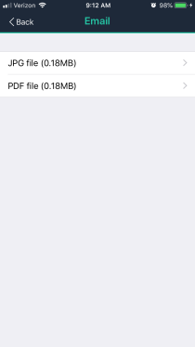
- Type the applicable email in the “To:” box.  - Click “Send” in the top, right-hand corner.  - How do you know who to send it to?  If your last name starts with letters A-J send it to Brenda at brendaj@lewthompsontrucking.com  If your last name starts with K-Z, send it to Lisa at lisa.ogden@lewthompsontrucking.com | 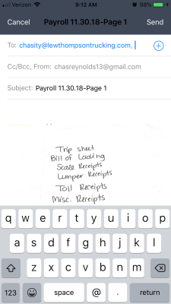
- You will be limited on how many documents you can store with the free version. Therefore, after you have turned in the original documents to payroll, you can return to the home screen (where all your scans are saved) and slide the document to the left. Click the icon and then click “Delete” when it pops-up below. | 